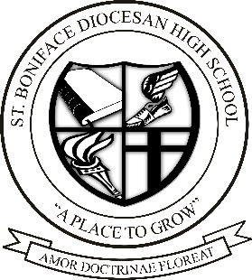

St. Boniface Diocesan High School
Invites applications for the position of
FULL-TIME TEACHER POSITION (SEPT 2023-JUNE 2024)

St. Boniface Diocesan High School is seeking an enthusiastic, hardworking individual for the position of a full-time teacher starting September 1, 2023 until the June 30, 2024 with the possibility of extension.

Subjects to teach during the 2023/24 school year include:
Physical Education & Health (Grade 9 & 10)
Grade 9 Social Studies
Grade 10 Geography
Successful applicants will:
- Hold a valid Manitoba Permanent Professional Certificate
- Demonstrate a teaching philosophy in keeping with Catholic education
- Have excellent interpersonal, communication and team skills

Preference will be given to individuals with knowledge/experience in:
- Strong background with the Physical Education & Health curriculum
- Work or practicum experience in a high school environment
- Coaching experience in school athletics

SBDHS is committed to equity, diversity, and inclusion. We recognize that a diverse staff enriches the working and learning environment of our school community. We welcome applications from all qualified individuals with diverse backgrounds.

Child Abuse Registry Check and Criminal Record Check documents will be required prior to commencement of employment.

Interested applicants should forward a resume, including two references, & a pastor’s recommendation or personal reference by May 5th, 2023 to the following email principal@sbdhs.net.

Only those who are being considered will be contacted. We thank you for your interest.

